**FINAL EXAM SOLUTIONS**

Q-1. You have 5 bowls containing, respectively, 10, 10, 20, 20 and 20 balls. Some balls in each bowl are white; the rest are black. The number of white balls in the bowls are, respectively, M, 10-M, 11, 4 and 15. A bowl is selected at random, and a single ball is drawn from that bowl at random. It is found that the ball drawn is **black**. Find the probability that the drawn **black** ball came from bowl #2.

From the given data, we get the total number of BLACK balls in the five bowls = 40.

P( bowl-2 | black-drawn )

= P( bowl-2 & black-drawn ) / P( black-drawn )

= P( black-drawn | bowl-2 ) * P( bowl-2 ) / P( black-drawn )

= [ M/10 * 1/5 ] / [ 40/80 ] = **M/25**

Q-2. A fair coin is tossed 10 times. Find the probability that it turns up HEAD exactly N-1 OR N times.

**Q-2 Answer = [ 10CN-1 + 10CN ]/1024**

**Q-3 Answer = sum of two shades areas**

**= [2N-8]/16 + [1/4 – (1/2)*M*(M/128)]**

**= [2N-8]/16 + ¼ - M^2/256**

pdf of continuous RV X



X = 0 X = 8 X = 20 X axis 🡪



Q-3. Given the probability density function shown above, find Prob( M <= X <= 2*N ).

Q-4. At a router, the number of packets arriving per millisecond, denoted by P, follows Poisson distribution, with mean rate of 2 packets per millisecond. Find Prob[ M < P < M+3 ]. Refer to the table below.

**Four entries in the table must be added, for count = M, M+1, M+2, M+3**

Q-5. The average working life of a certain power supply is claimed to be 10000 hours, with standard deviation of 400*M hours. We test a sample of size 25 of the power supplies, and calculate the sample mean. Find the probability that the sample mean is between 9600 and 10400 hours.

**Answer:** 400*M/5 = **80*M** 🡪 standard deviation of sample mean

So number of standard deviations on either side = 400/(80*M) = 5/M

So answer = **2*F(5/M) – 1, where F(z) is the standard normal cdf**

Q-6. Five pairs of values of random variables X and Y are tabulated below. Find the COVARIANCE of Y & X.

|  |  |  |  |  |  |
| --- | --- | --- | --- | --- | --- |
| X | 1 | 2 | 3 | 4 | 5 |
| Y | -3M | -4M | 0 | 3M | 4M |
| X-mean | -2 | -1 | 0 | 1 | 2 |
| Product | 6M | 4M | 0 | 3M | 8M |

**Sum of DX*DY product = 21M 🡪 answer = 21M/5 = 4.2*M**

Q-7. Trucks arrive at a toll booth at the average rate of 12 arrivals per hour, and the arrivals define a Poisson process. What is the probability that the time interval T between two successive arrivals, measured in minutes, satisfies M < T < N?

**Answer: e-M/5 – e-N/5**, since the rate of arrivals is 1/5 per minute.

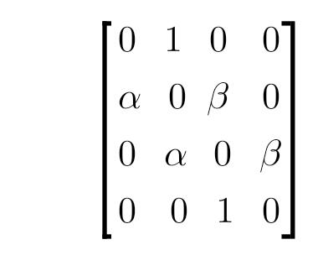Q-8. Recall the Markov process defined as "random walk with reflecting barriers". The four states of the process are 1, 2, 3 and 4. The transition probability matrix is as given below, with a = M/10. The initial probability distribution over states is (1/4, 1/4, 1/4, 1/4). What is the probability that the process is in state 1 after two time steps?

**Pre-multiply TWICE above matrix with the probability matrix. After one pre-multiplication, probability distribution = ( a/4 (1+a)/4 (1+b)/4 b/4 ). After the second round, only the first element of the row is needed, so only one column multiplication is needed.**

**So answer = a(1+a)/4 = (M/10)*(1+M/10)/4 = M*(M+10)/400**